Methods of Moments (MoM) & Maximum Likelihood Estimation (MLE)

Methods of Moments (MoM) and Maximum Likelihood Estimation (MLE) are two widely used techniques for parameter estimation in statistics. Here’s a detailed comparison and explanation of each:

1. Methods of Moments (MoM)
The Method of Moments estimates parameters by equating sample moments (e.g., mean, variance) to theoretical moments derived from a probability distribution.

Steps in MoM:
- Compute the sample moments (e.g., sample mean, variance) from the observed data.
- Equate these sample moments to the corresponding theoretical moments of the distribution (expressed as functions of parameters).
- Solve the resulting equations for the parameters.

Example of MoM for a Normal Distribution

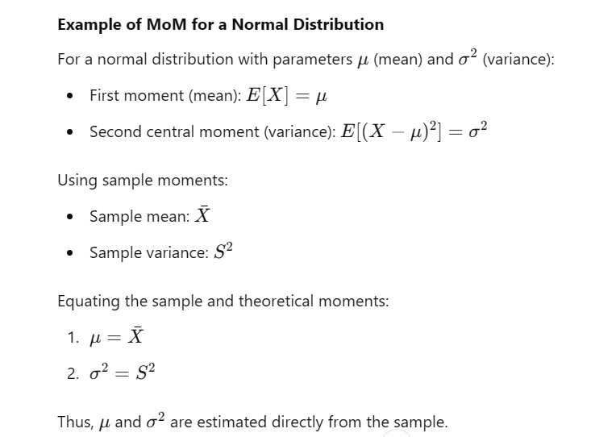

2. Maximum Likelihood Estimation (MLE)
The Maximum Likelihood Estimation method identifies the parameter values that maximize the likelihood function, which represents the probability of observing the given data under the assumed model.

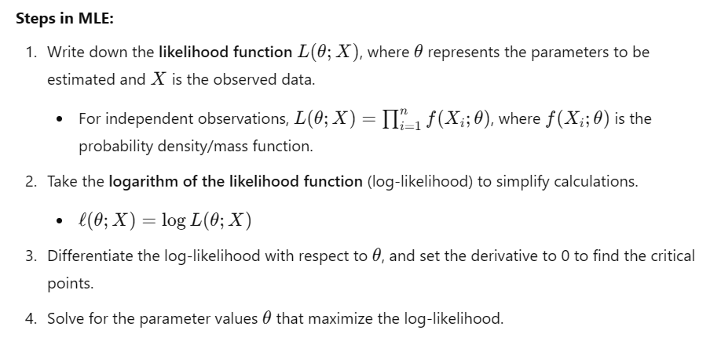
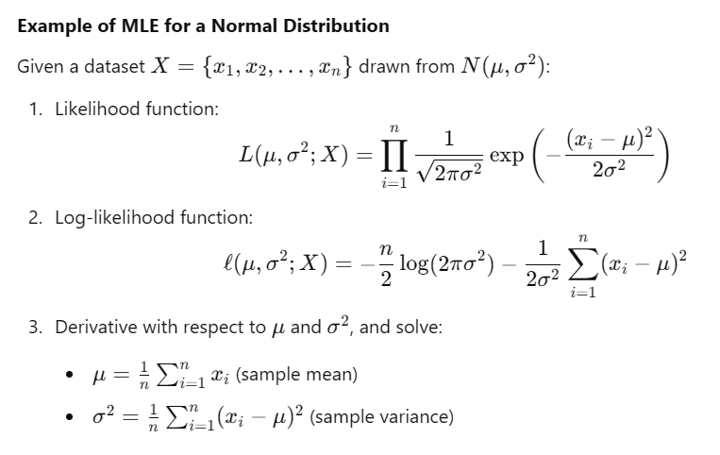

Comparison: Methods of Moments vs. MLE

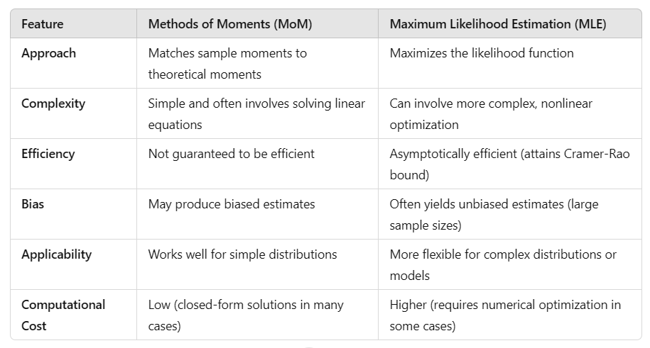

When to Use:
- MoM is often used for quick, approximate solutions when computational simplicity is essential.
- MLE is preferred when accuracy and efficiency are critical, especially in larger datasets or more complex models.

